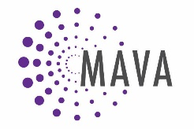
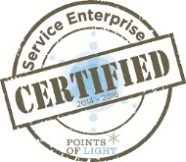
Position Description

MAVA Overview:
The Minnesota Association for Volunteer Administration (MAVA) connects, educates, strengthens and advocates for volunteer engagement leaders and their organizations to positively impact communities. MAVA has over 700 members statewide. MAVA works to build capacity for hundreds of organizations and government entities.

MAVA seeks to benefit from diversity of volunteer backgrounds, skills sets and knowledge base.

Position: Partnership & Development Assistant (volunteer-intern).

Purpose of Position: This position is responsible for working with the executive director and development manager to develop and sustain partnerships and funding relationships with corporations, businesses, organizations and government entities.

Accountable To: Executive Director

Responsibilities:
- Develop outreach plan and tools in order to promote funding and sponsorship opportunities for MAVA.
- Reach out to, correspond with and meet with corporations, businesses, organizations and government entities in order to promote MAVA initiatives and partnerships.
- Assist with writing grants to foundations.
- Seek sponsorships for MAVA programs and fundraising events.

Skills needed:
- Outgoing and “can do” approach
- Effective communicator, both written and oral
- Proactive and organized
- Strong writing and editing skills
- Interest in nonprofits or the field of volunteer engagement

Benefits:
- Build your business development and fundraising portfolio
- Professional experience; letters of recommendation
- Use your creativity to promote volunteerism across Minnesota
- Free MAVA membership while volunteering, including discounts on MAVA-sponsored events. Visit www.mavanetwork.org/membership for membership benefits.
- Transportation stipends may be available.
- Work remotely; some work from MAVA office may be needed.

Time commitment: Minimum 5 hours/week

People of Color are encouraged to apply.

Send resume and/or letter of interest to kbulman@mavanetwork.org

