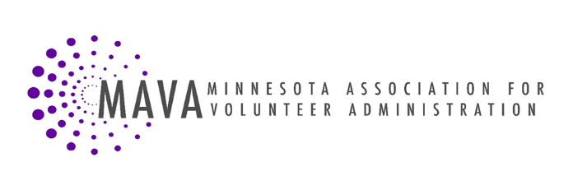

Position Description

Position: Public Affairs Committee Member

Purpose of Position: Advocate on behalf of volunteers and leaders of volunteer programs on issues of importance to promoting volunteerism and advancing the profession of volunteer administration. Study and provide information/education on public affairs issues of interest to MAVA Members.

Accountable To: Public Affairs Chair
Term: 1 year

Responsibilities:
- Participate in Public Affairs Committee meetings.
- Work with committee to solicit information from MAVA Members and others on timely public affairs issues impacting MAVA Members and the volunteer community.
- Work with committee to make recommendations to the MAVA Board and Membership with regard to MAVA’s platform and public affairs positions.
- Work with committee to implement advocacy actions as indicated in the public policy platform.
- Work with committee to develop plan for communication to membership when rapid response is needed. Provide rapid response on legislation and public policy issues.
- Identify strategic partnership opportunities for MAVA, especially in relationship to units of government.
- Collaborate with other organizations across the state to achieve goals.

Skills Needed:
- Experience or interest in public affairs work, grassroots organizing or advocacy
- Interest in or knowledge of legislative process
- Ability to collaborate with other organizations
- Excellent written and oral communications skills
Benefits:
- Experience in advocating on issues of importance to volunteerism.
- Make contacts with key leaders across state.
- Enhance management skills through a leadership position in a statewide association

Print Name______________________________________________________________________

Signature_________________________________________ Date______________________

